A picture containing clipart

Description generated with very high confidence

Azure 103 Module 2

Hands On - 17

Azure Certification Training

[**support@intellipaat.com**](mailto:support@intellipaat.com)

**+91-7022374614**

**US: 1-800-216-8930(Toll Free)**

**Azure 103 Module 2, Hands On – 17**

**Creating and using Azure CDN Endpoints**

**Step 1:** Create a storage account for Blob Storage and upload a few images. If you don’t know how to create a blob storage, please refer previous hands on about BLOB Storage.

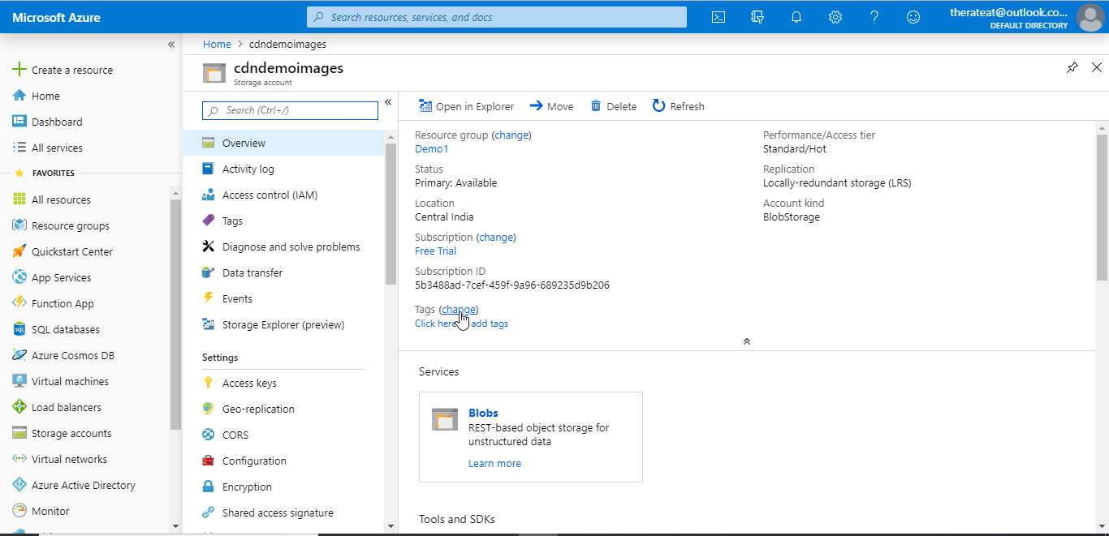

**Step 2:** In the Azure Portal’s Homepage search for CDN Profiles.

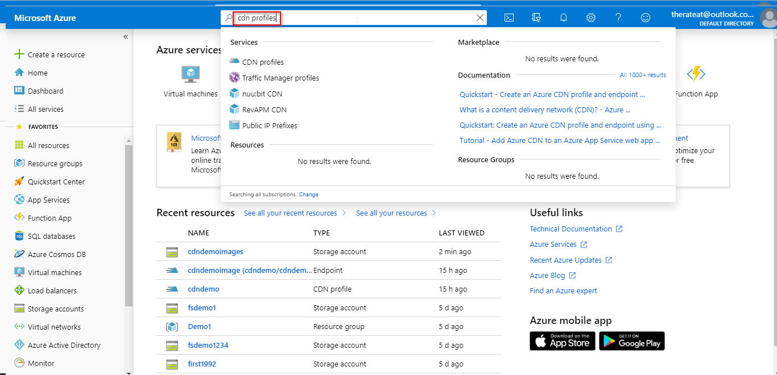

**Step 3:** Click on CDN Profiles.

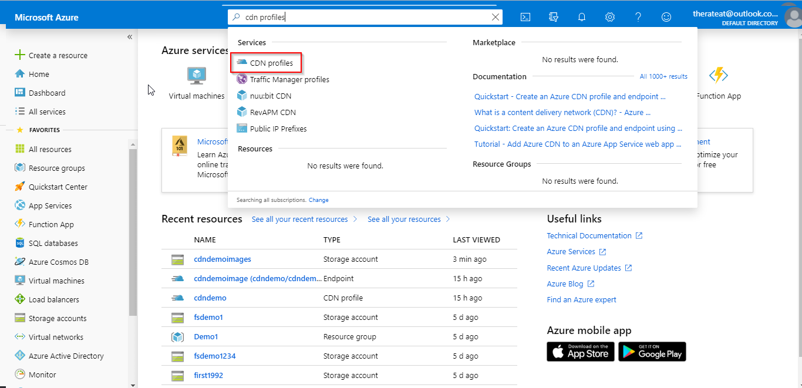

**Step 4:** Click on ‘+ Add’.

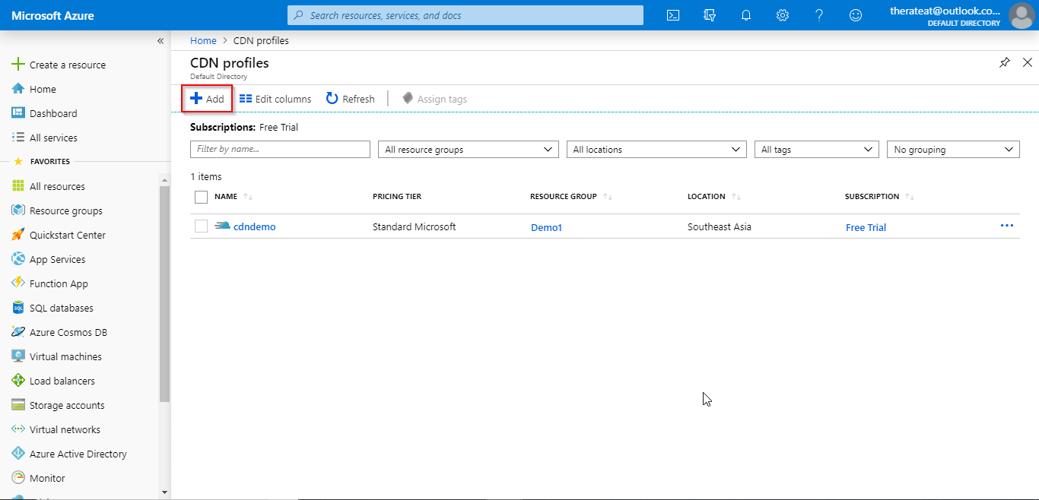

**Step 5:** Fill the details and click on create.

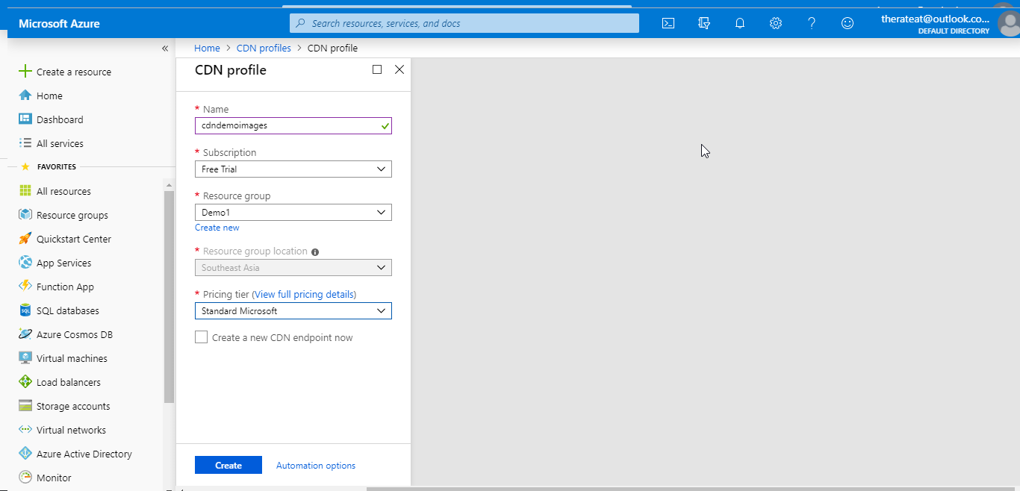

**Step 6:** Click on the CDN Profile just created.

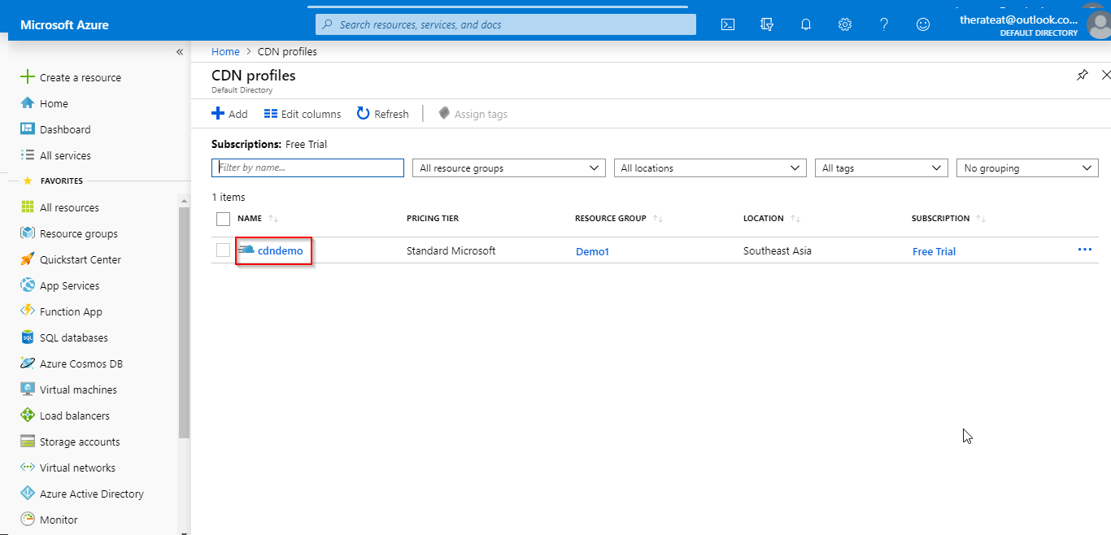

**Step 7:** Click on the ‘+ Endpoint’.

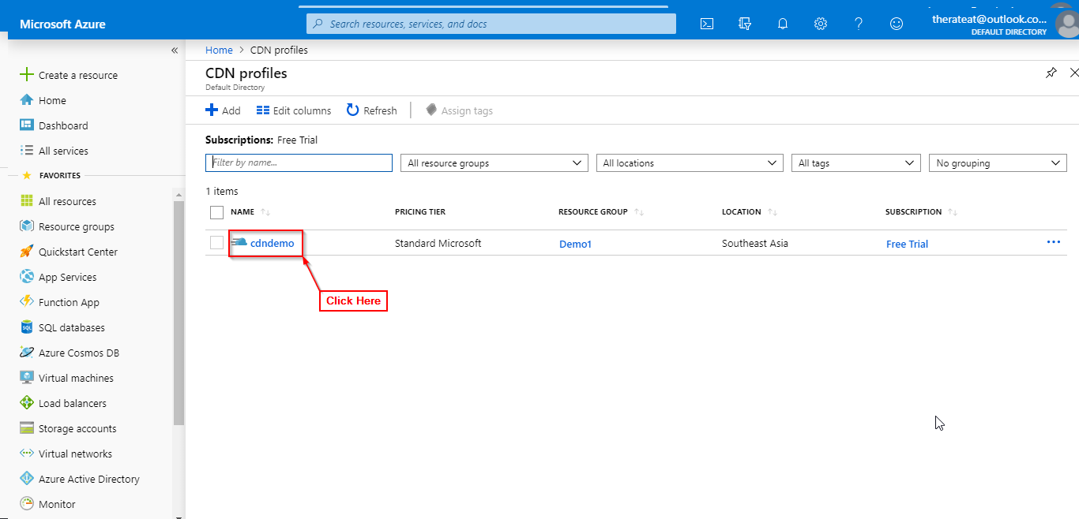

**Step 8:** Enter the details (Select origin type as storage and origin hostname as the URI of the storage file you created in previous steps) and click on add.

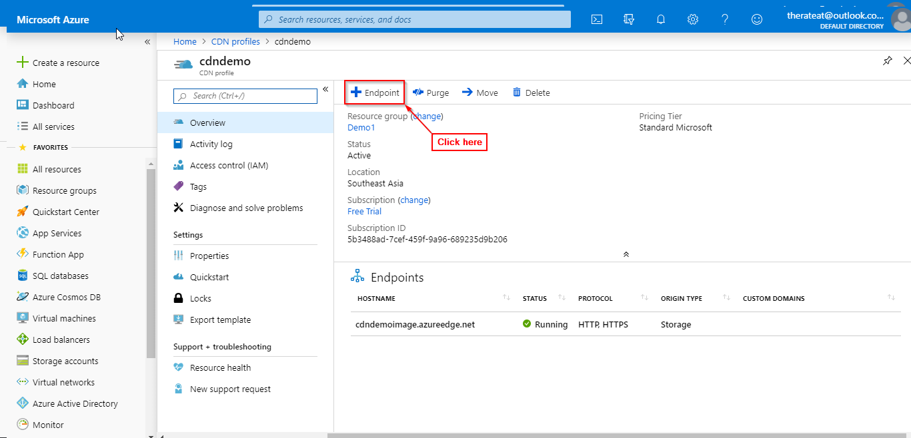

**Step 9:** After the CDN Endpoint is created wait for 10 minutes for the files to propagate on the CDN Network.

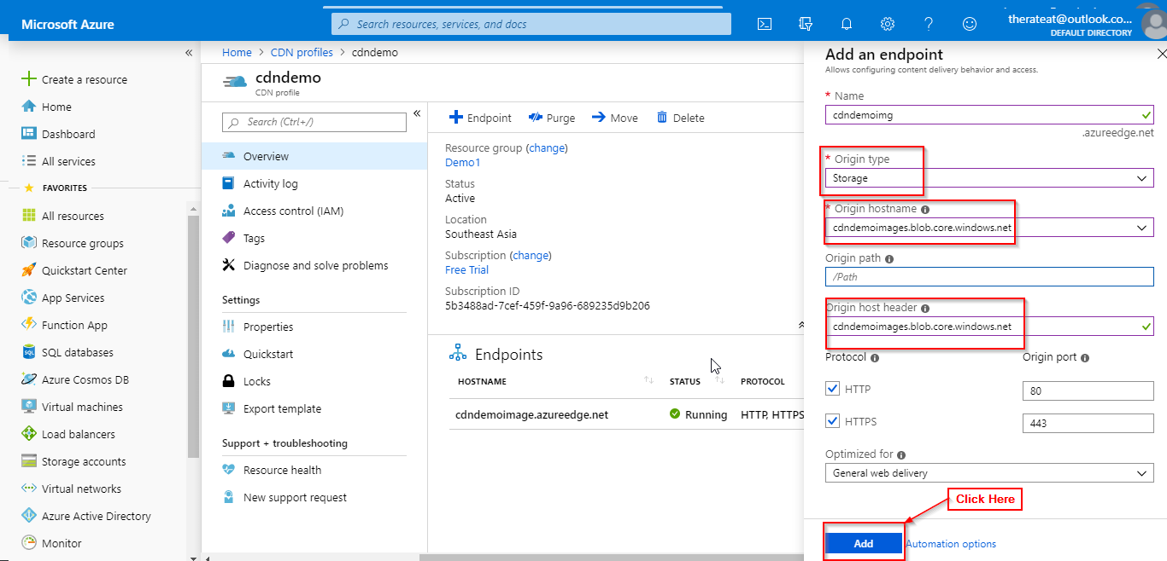

**Step 10:** Click on the CDN endpoint.

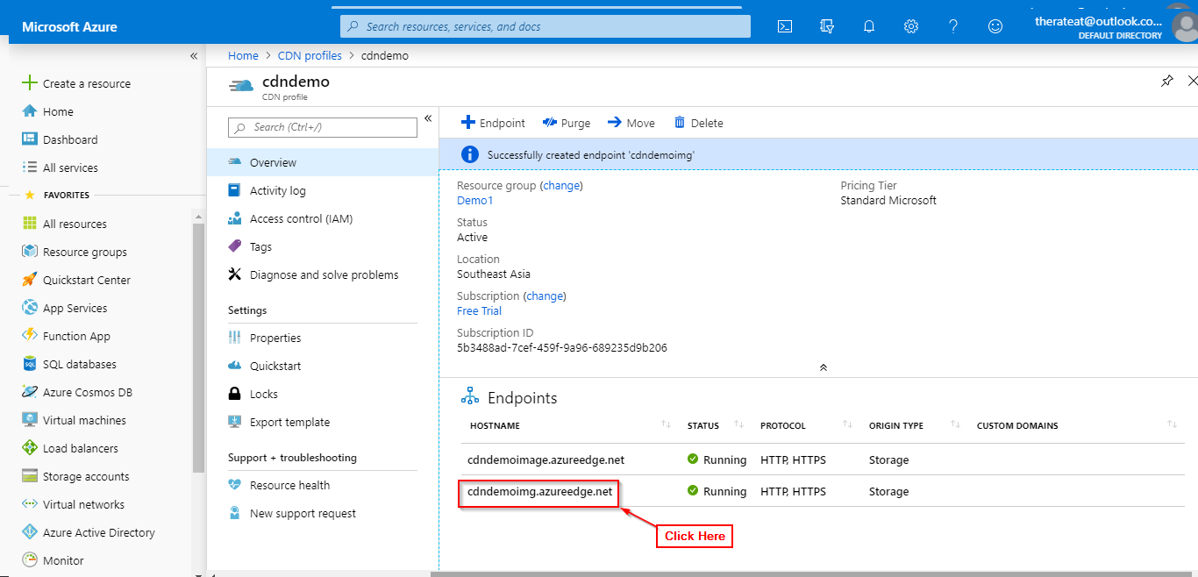

**Step 11:** Copy the endpoint hostname.

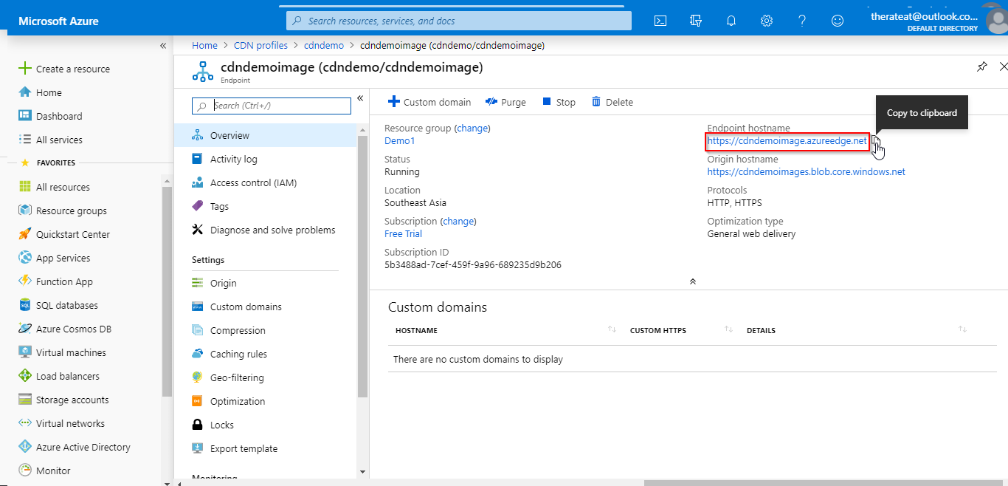

**Step 12:** Open the blob storage copy the file URI.

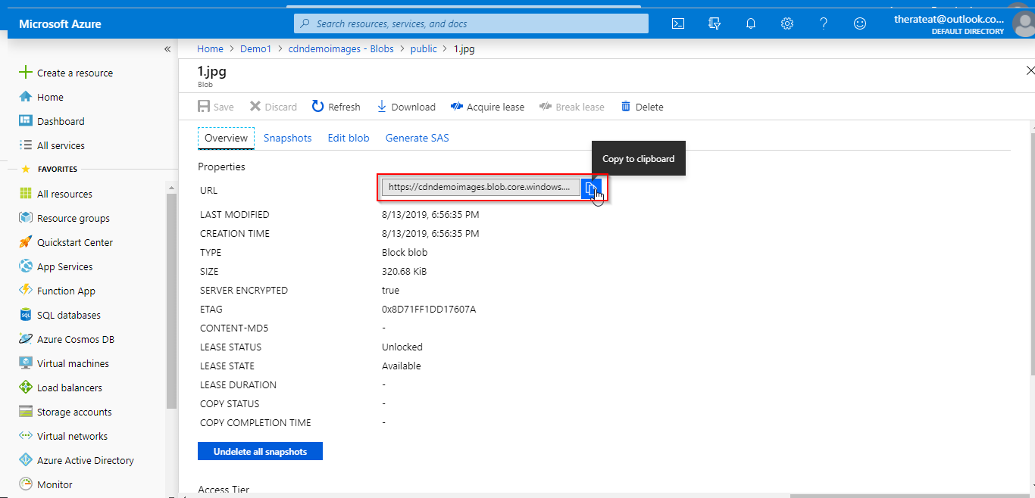

**Step 13** Replace the BLOB container URI with the CDN URI.

